FIELD DAY TEAM LEADERS SHEET

GET A WALKIE-TALKIE WHEN YOU ARRIVE. At 9am, go to each classroom to collect the children on your list. Make sure you know how many
kids you have by marking them on this attendance sheet. Then
follow the schedule and proceed to your first station at 9:10am.
SNACK: MAKE SURE to note any allergies or dietary concerns.
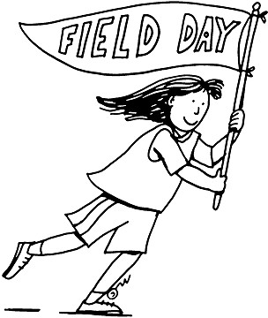

Group A (TEAM LEADER – )
Child – age 3 (gluten free) | Child – age 4 (peanut allergy)
Child – age 3 | Child – age 4
Child – age 3 | Child – age 5
Child – age 4 | Child – age 5
Child – age 4 | Child – age 5

Group Rotation Schedule:

1st 2nd 3rd 4th 5th 6th
Free Play: --- A B C D ---
Snack: A B C D --- ---
Activity #1: B C D --- --- A
Activity #2: C D --- --- A B
Activity #3: D --- --- A B C
Activity #4: --- --- A B C D

