Will it
SINK or FLOAT?
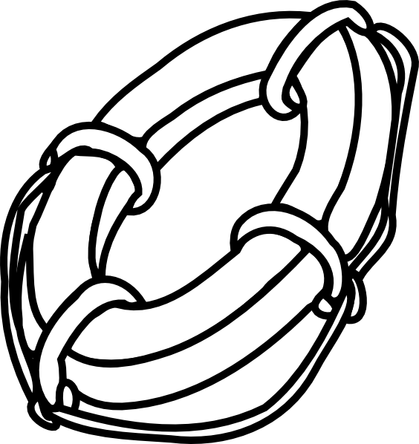
Item | Guess | Actual
The SEEDS Network, LLC www.theseedsnetwork.com

